4235668 - Workpapers - Last modified date column
Add last edit/modified date for documents as a workpapers column (Epic 4235668)1. Customer Problemlack quick visibility into document freshness and edits after signoff.
2. Customer Researchshow last modified in tree and list to confirm progress and detect post-signoff changes.
3. Our SolutionAdd Last Modified column (and tooltip) in list and tree.
- Respect permissions and reflect add-in saves.
Dependencies: document service metadata, UI components.
4. Product MetricsTime to assess workpaper freshness: -60%.
- Post-signoff edit detection rate surfaced: +100%.
Appendix: Child Features3413817 Add last edit date / modified date for documents as a workpapers column
Appendix: LinksHYPERLINK "https://dev.azure.com/tr-tax/TaxProf/_workitems/edit/4235668"Open Epic 4235668

Appendix: Quick prototype
Figure: PDF page 67
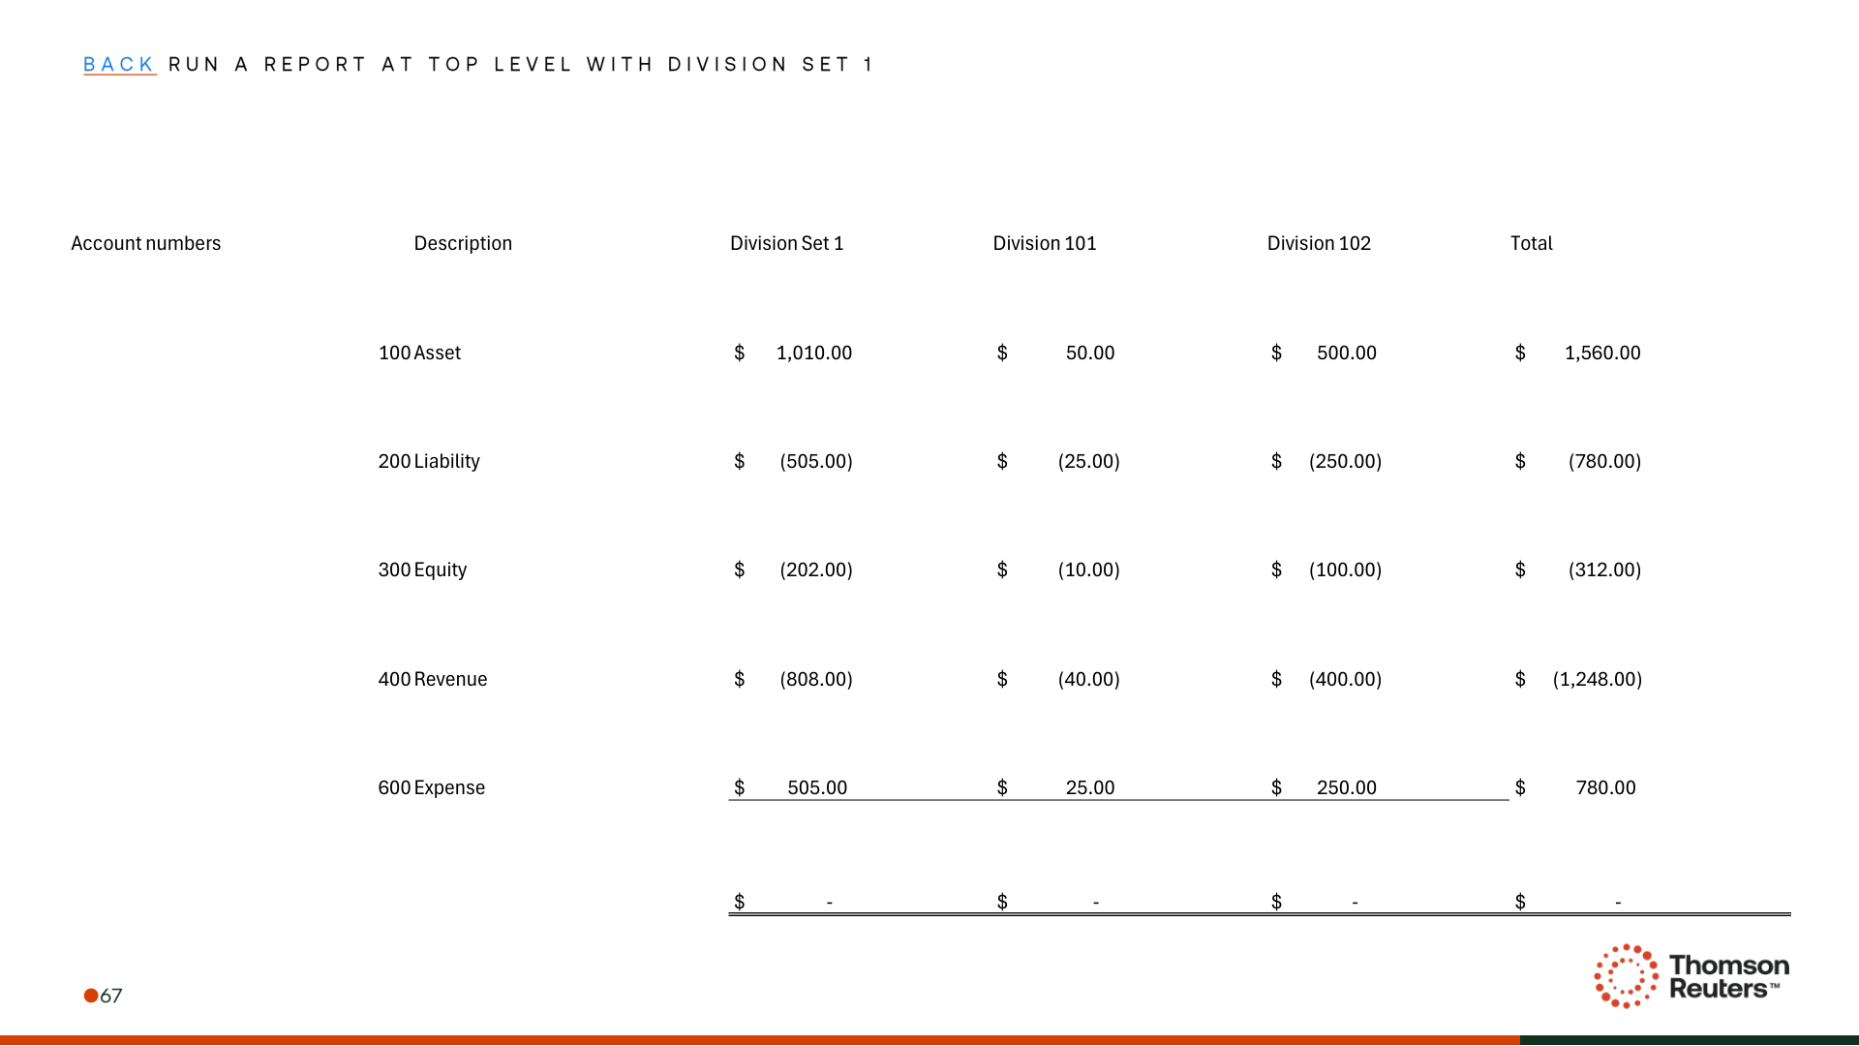
Figure: PDF page 71
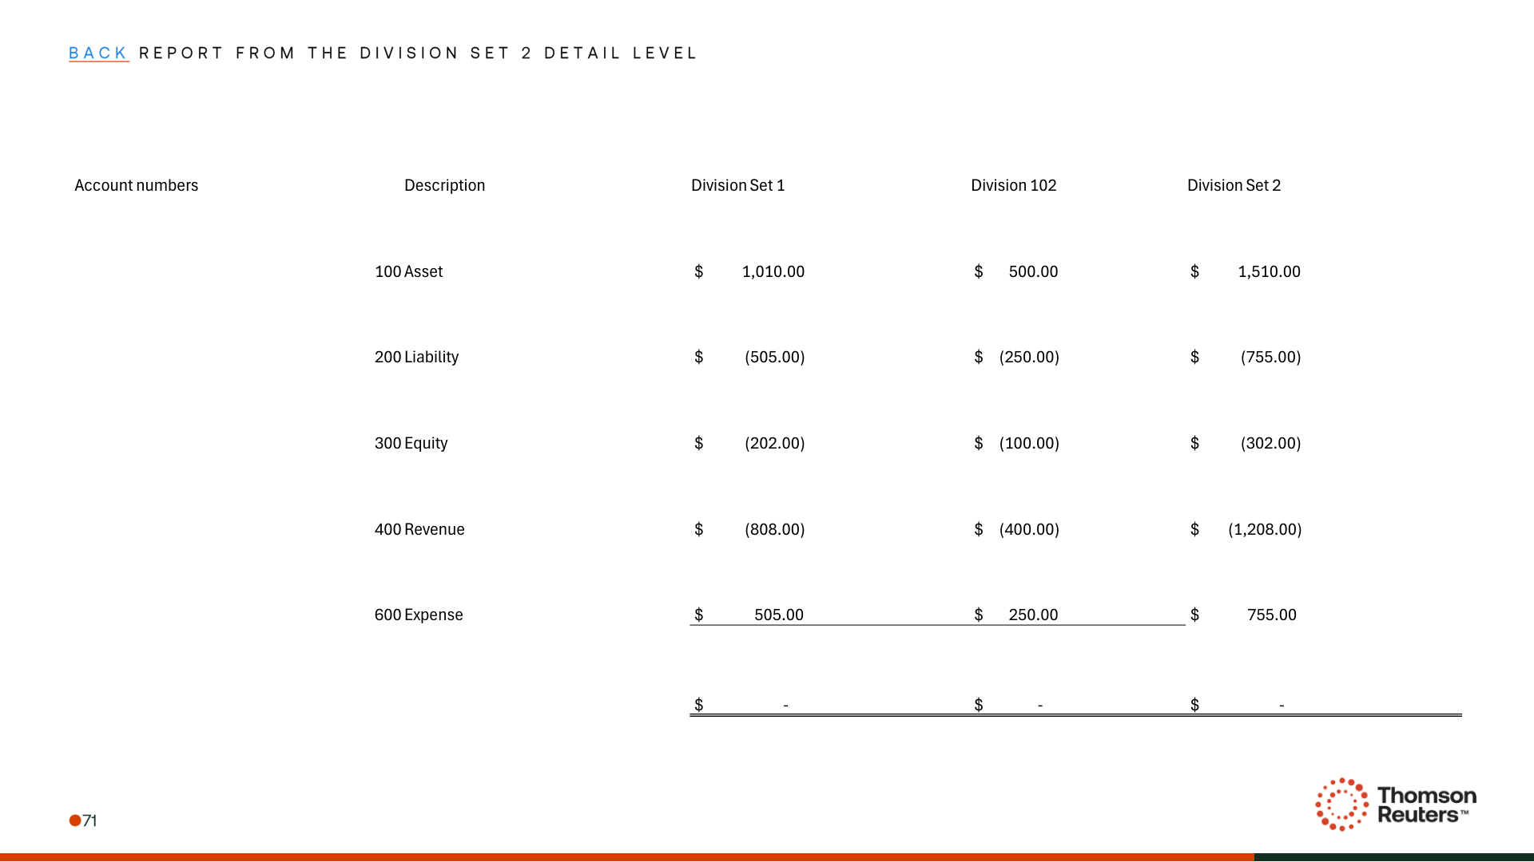
Figure: PDF page 72
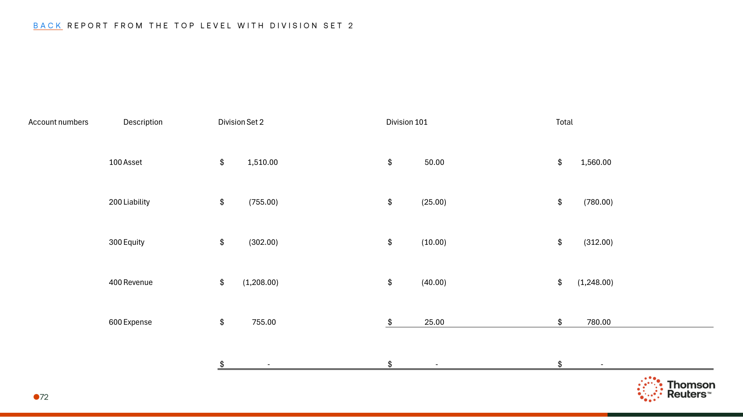

Appendix: Links
ADO Epic Link: https://dev.azure.com/tr-tax/TaxProf/_workitems/edit/4235668

